PROJECT REVISION LIST

Legend:

|  |  |
| --- | --- |
|  | Done |
|  | Need rework |
|  | Not yet done |

|  |  |  |  |  |  |  |  |
| --- | --- | --- | --- | --- | --- | --- | --- |
| **No.** | **RECOMMENDATION/**  **FEEDBACK** | **Action Taken by the Team Member/s** | **Comment by Panel Member** | | | | |
| **PM1** | **PM2** | **PM3** | **PM4** | **PM5** |
| 1. 1 | Combined Login Page for Admin & Adviser | Created a separate login page for Advisers |  |  |  |  |  |
|  | Student’s Project | Created a Project page where students can create and view their project. |  |  |  |  |  |
|  | Student’s Project Limitation | Modified the ‘Add Project’ button to disable after the student create their project |  |  |  |  |  |
|  | Tasks can be assigned to students. | Added Task assignment feature for Admin/Dean |  |  |  |  |  |
|  | Tasks should be organized by prerequisites | Tasks are organized in accordion-style per prerequisites |  |  |  |  |  |
|  | Assigning of Project Advisers | Added List of Advisers students can choose from |  |  |  |  |  |
|  | Students’ application to Adviser | Advisers are notified whenever students choose their advisory;  Adviser can either Accept or Dismiss this application. |  |  |  |  |  |
|  | Add team/slots counter | Added team/slots counter for number of advisees per advisers |  |  |  |  |  |
|  | Identify the team | Added a Team Name label for each student’s team |  |  |  |  |  |
|  | Admin can see the task submitted by the students | Added a ‘Submission Page’ for Admin to view student’s submission |  |  |  |  |  |
|  | Advisers can see the task submitted by their advisee | Added a ‘Submission Page’ for Advisers to view their advisee’s submission |  |  |  |  |  |
|  | Status for tasks (ex: Reviewed etc.) | Added Status feature where Advisers can ‘Review’ and ‘Approve’ advisee’s submissions;  Admin can also see the status of the tasks if it was ‘reviewed’ by the Adviser |  |  |  |  |  |
|  | Project Page for Advisers | Added a ‘Project Page’ for Advisers to view the projects of their advisees |  |  |  |  |  |
|  | Project Advisers | Admin can add/delete Advisers |  |  |  |  |  |
|  | Slots available per Project Adviser | Added a counter per Adviser that will show the available slots of advisees still available |  |  |  |  |  |
|  | Project Adviser’s List of Advisees | Admin can see the students under each Project Adviser |  |  |  |  |  |
|  | Uploading of files is not working (including Profile Photo, Project Logo and Attachments of Tasks) | Debugged and fix this issue |  |  |  |  |  |
|  | Adviser should see the Project of each student | Added a Advisee profile page in Adviser side |  |  |  |  |  |
|  | Student should see the number of slots available advisee per adviser upon choosing them | Added a slot counter in each Adviser Card |  |  |  |  |  |
|  | Files submission bug |  |  |  |  |  |  |
|  | Status of tasks on the Task Page is not indicated | Added a status of Pending, Submitted and Reviewed to indicate the status of each task |  |  |  |  |  |
|  | Submission Table error |  |  |  |  |  |  |
|  | Adviser choosing should have status |  |  |  |  |  |  |
|  | Actions in Submissions |  |  |  |  |  |  |
|  | Submission classifications |  |  |  |  |  |  |

1. Adviser side to. Gamit ko yung account ni Mam Denise, and si Ken lang yung under ng advisee ko. Dapat kung sino lang yung mga advisee ko yun lang yung makikita kong submission dito. This applies to all of the Adviser din. - Done

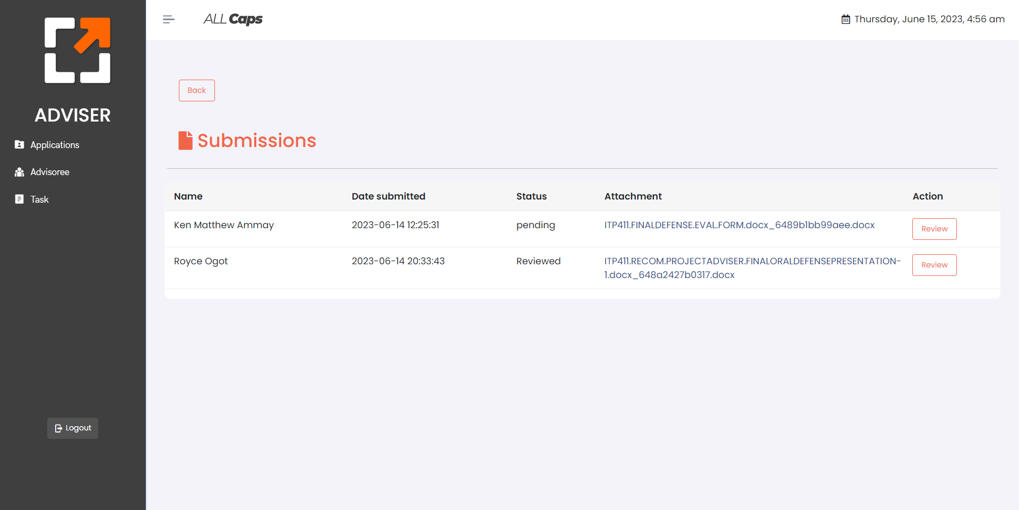

1. Ang nangyayari dito, Nakakapagsubmit ako kahit wala akong inaattach na file. Kung pepwede sana gamitan ng condition or Swal, para kung sakali na pindutin yung submit nang walang naka attach, may magpapop up na “You haven’t attached your submission” or something like that.   
     
   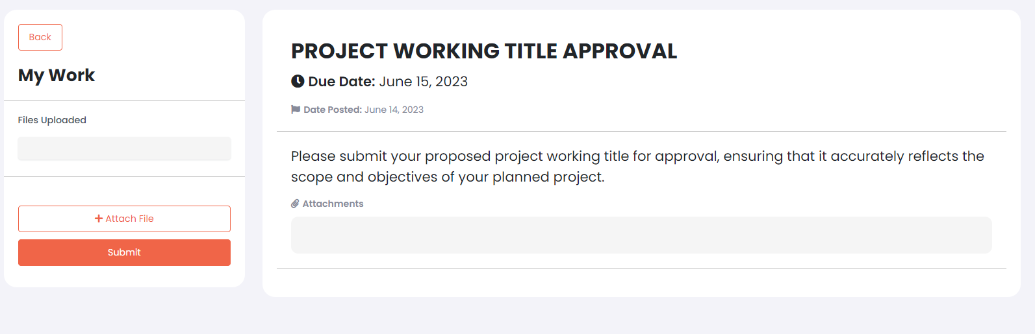

23. Ganito yung UI pag hindi pa nakakapili ng Adviser si student.

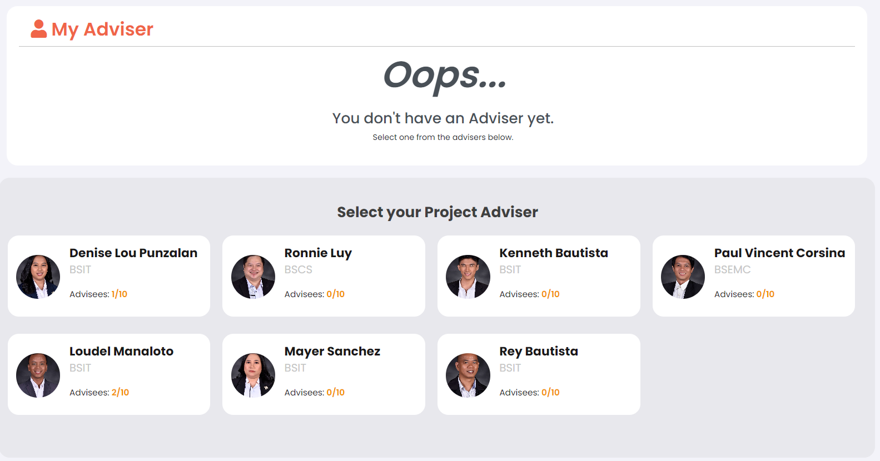

Ganito naman yung UI pag nakakapili na ng Adviser si student. Ang Problema dito, hindi pala dapat agad agad na makakachoose ka ng Adviser and magshoshow agad dito.

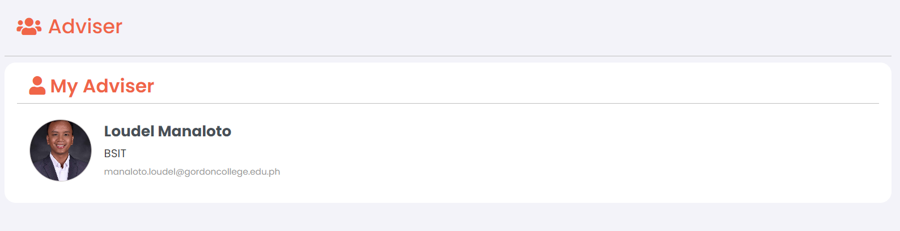

Kasi diba, need pa iaccept dito ni Adviser yung application ng student.

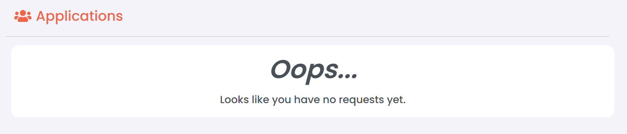

So, Kailangan niya ng **status** na kagaya nito sa taas. For example, “**Your application to Loudel Manaloto’s Advisory is still pending**.” Then kung iaccept ni adviser yung application, doon lang lalabas yung profile ng chosen adviser niya sa may ‘*My Adviser’.*

24. Goods na gumagana itong button para masabing reviewed na yung submission ni student. May suggestion here is, after maclick ni Adviser yung Review button, magiging disabled na siya, meaning hindi ko na ulit mapipindot.

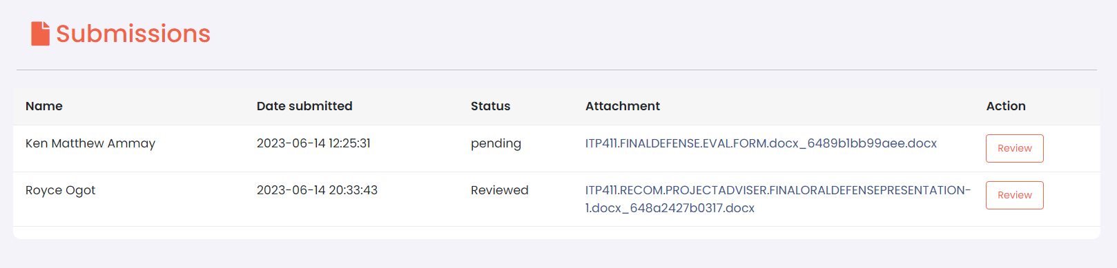

25. Bali ito yung UI niya initially. Pero tinanggal ko yung status sa table at ginawan ko siya ng designated na space niya.

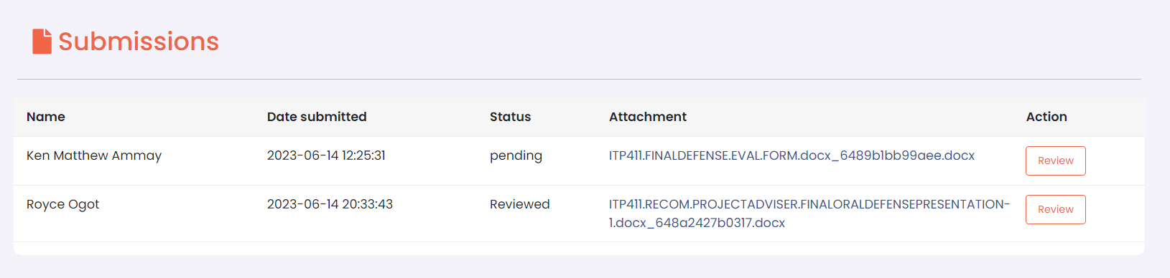

Bali ganito na yung bago niyang UI. After siguro maclick si review, mapupunta na yung submission doon sa **‘Completed’**  and doon natin iiimplement yung Status. Ang matitira nalang na nasa Submission Table ay yung mga hindi pa narereview ni Adviser.  
  
Di ko pa nababago yung UI ng sa Admin Side, pero ganito din sana yung maging itsura ng process.

